Introduction to Automotive

Report

Lab 6: Hydraulic Assist

|  |  |
| --- | --- |
| Student Name | Ahmed Mohsen Abd El Fattah |
| ID | 1901061 |

# Hydraulic Assist:

The hydraulic assist system is designed to aid drivers in braking within shorter distances, particularly beneficial for those with less experience or in challenging driving conditions. It operates by integrating two key inputs: the speed at which the driver depresses the pedal and the extent of pressure applied. Utilizing these inputs, the system provides assistance tailored to the driver's actions, effectively enhancing braking performance. By responding to both the rate and magnitude of pedal input, hydraulic assist ensures smoother, more controlled braking, contributing to overall safety on the road.

# MATLAB Snippets:

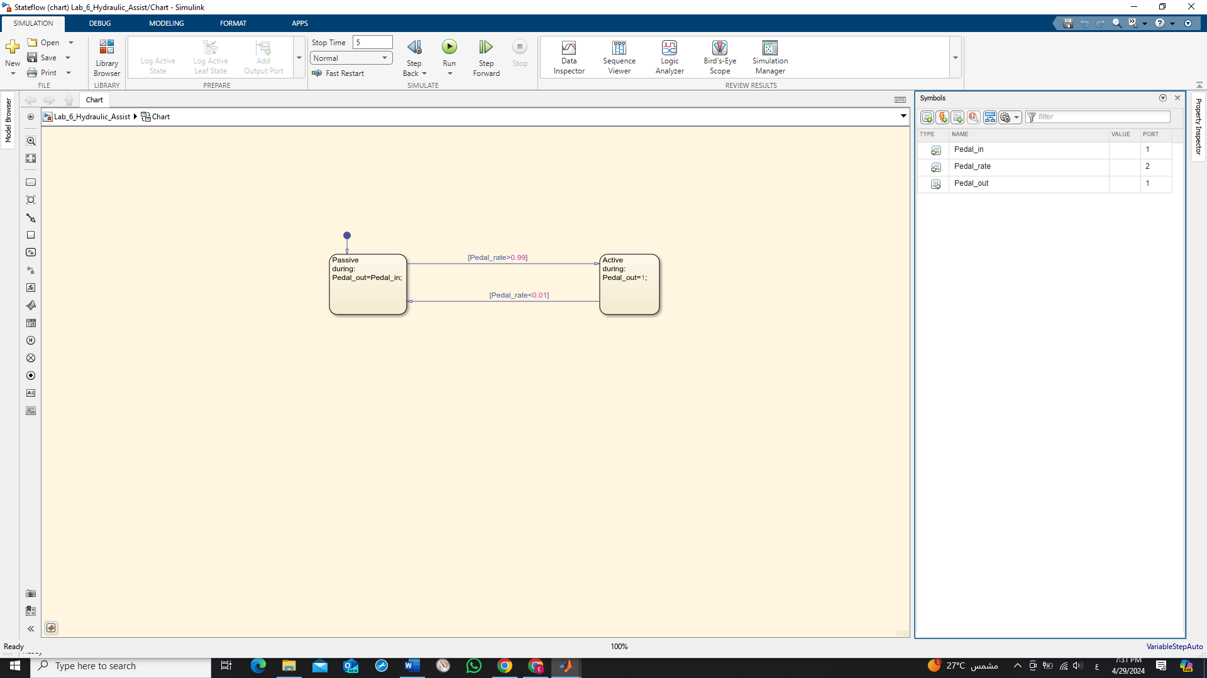

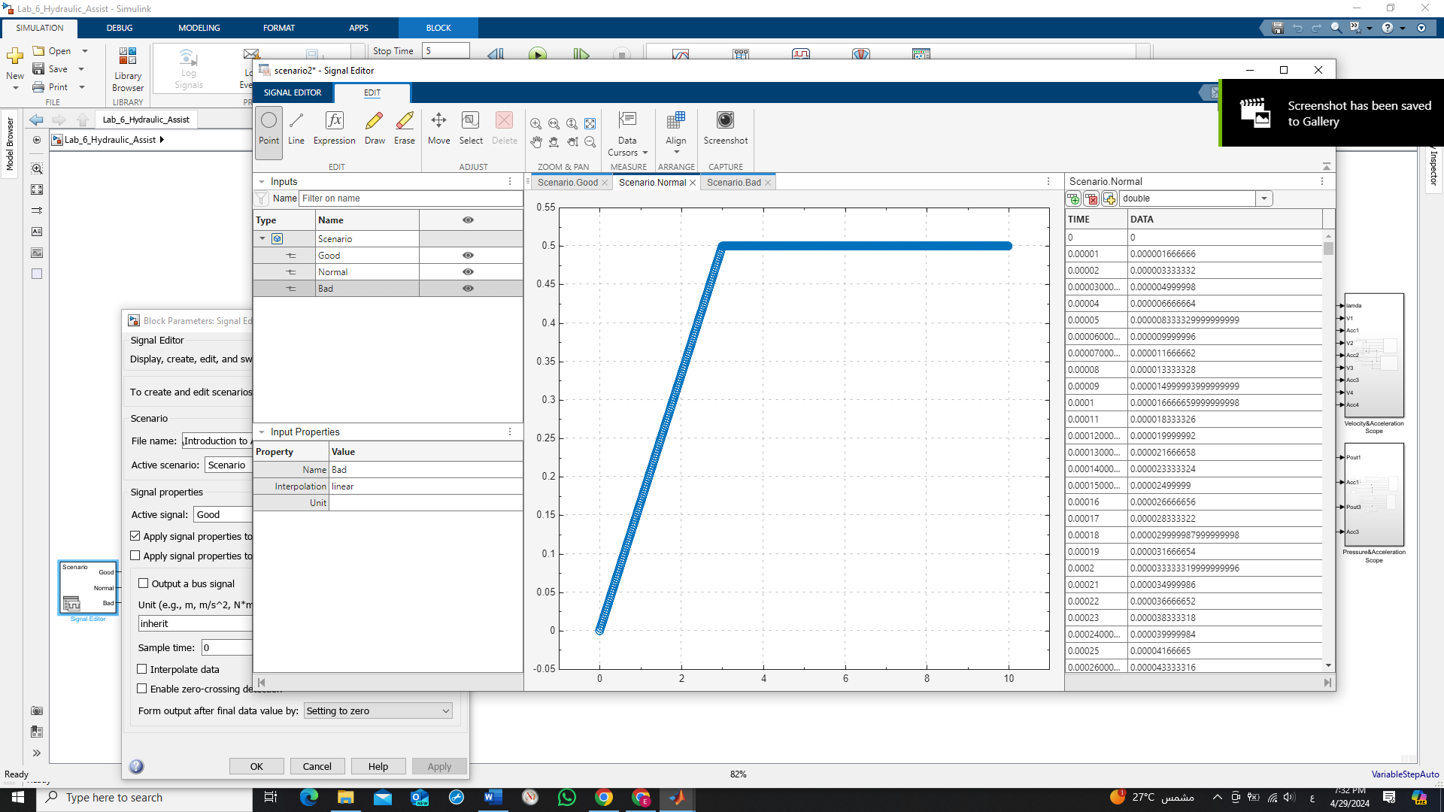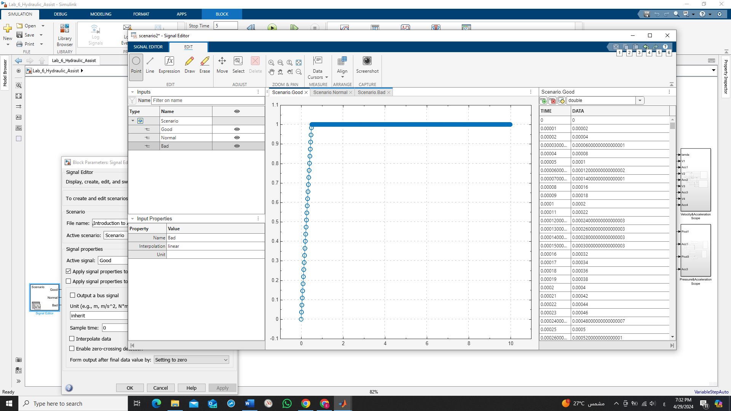

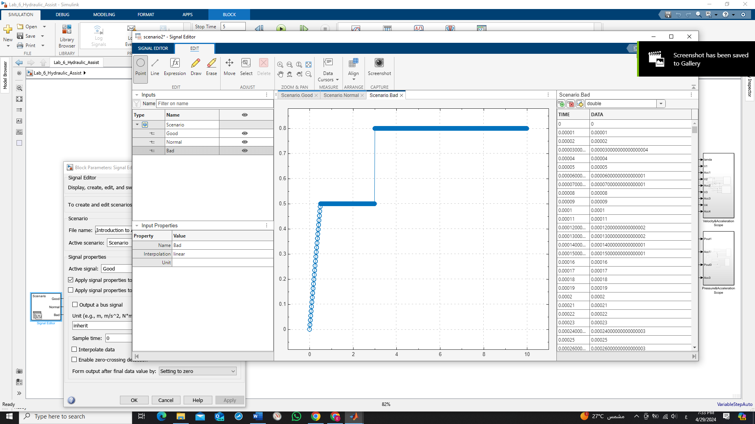



# Comments:

* The algorithm has assisted the bad driver the most and lowered the stopping distance.